File system files making guide
- Introduction
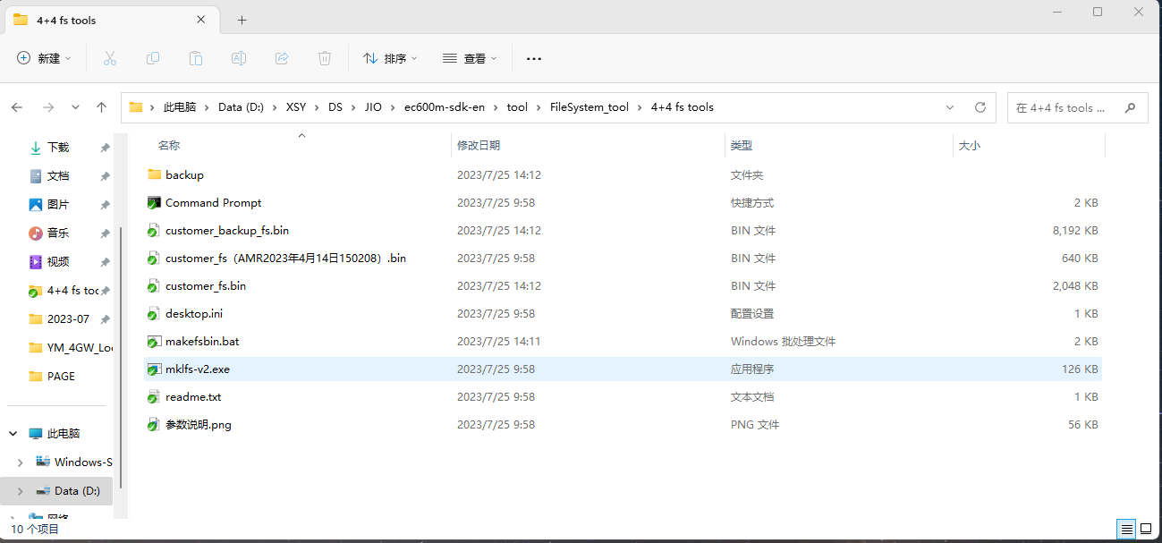
- Backup-The folder contains the directory of system/audio files, and store import files and export files from customer_fs.bin under this folder
- customer_fs.bin is input/output FS file that used by this tool（customer_backup_fs.bin – external flash file system，if making external file system, need manually rename）
- makefsbin.bat – batch file
- FS file generate
- Place the system/audio files to be imported in the backup folder
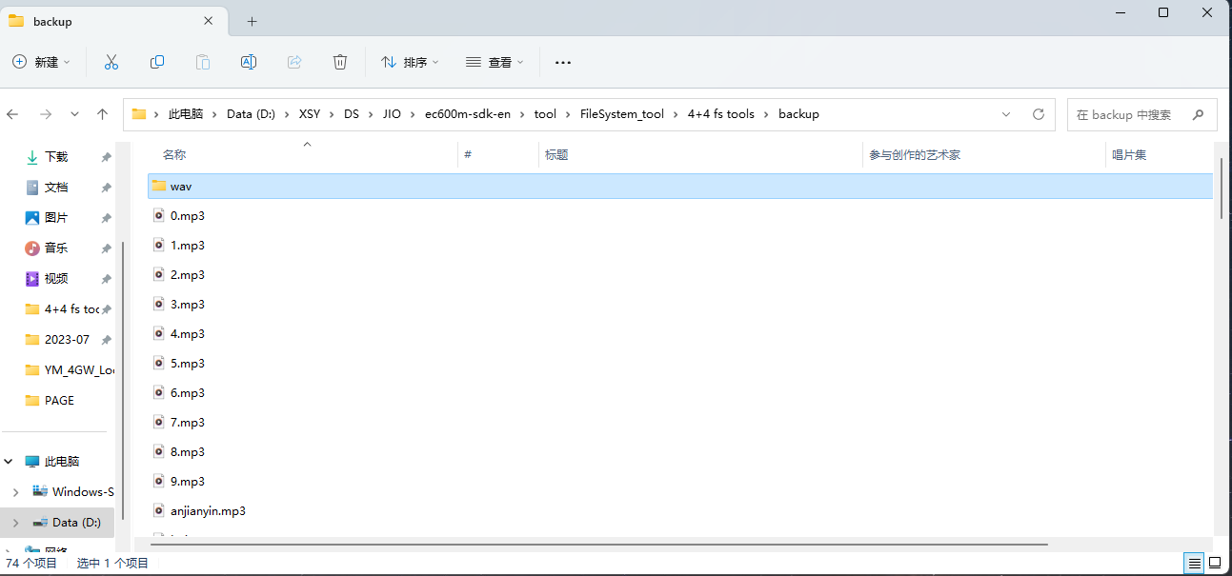
- run makefsbin.bat
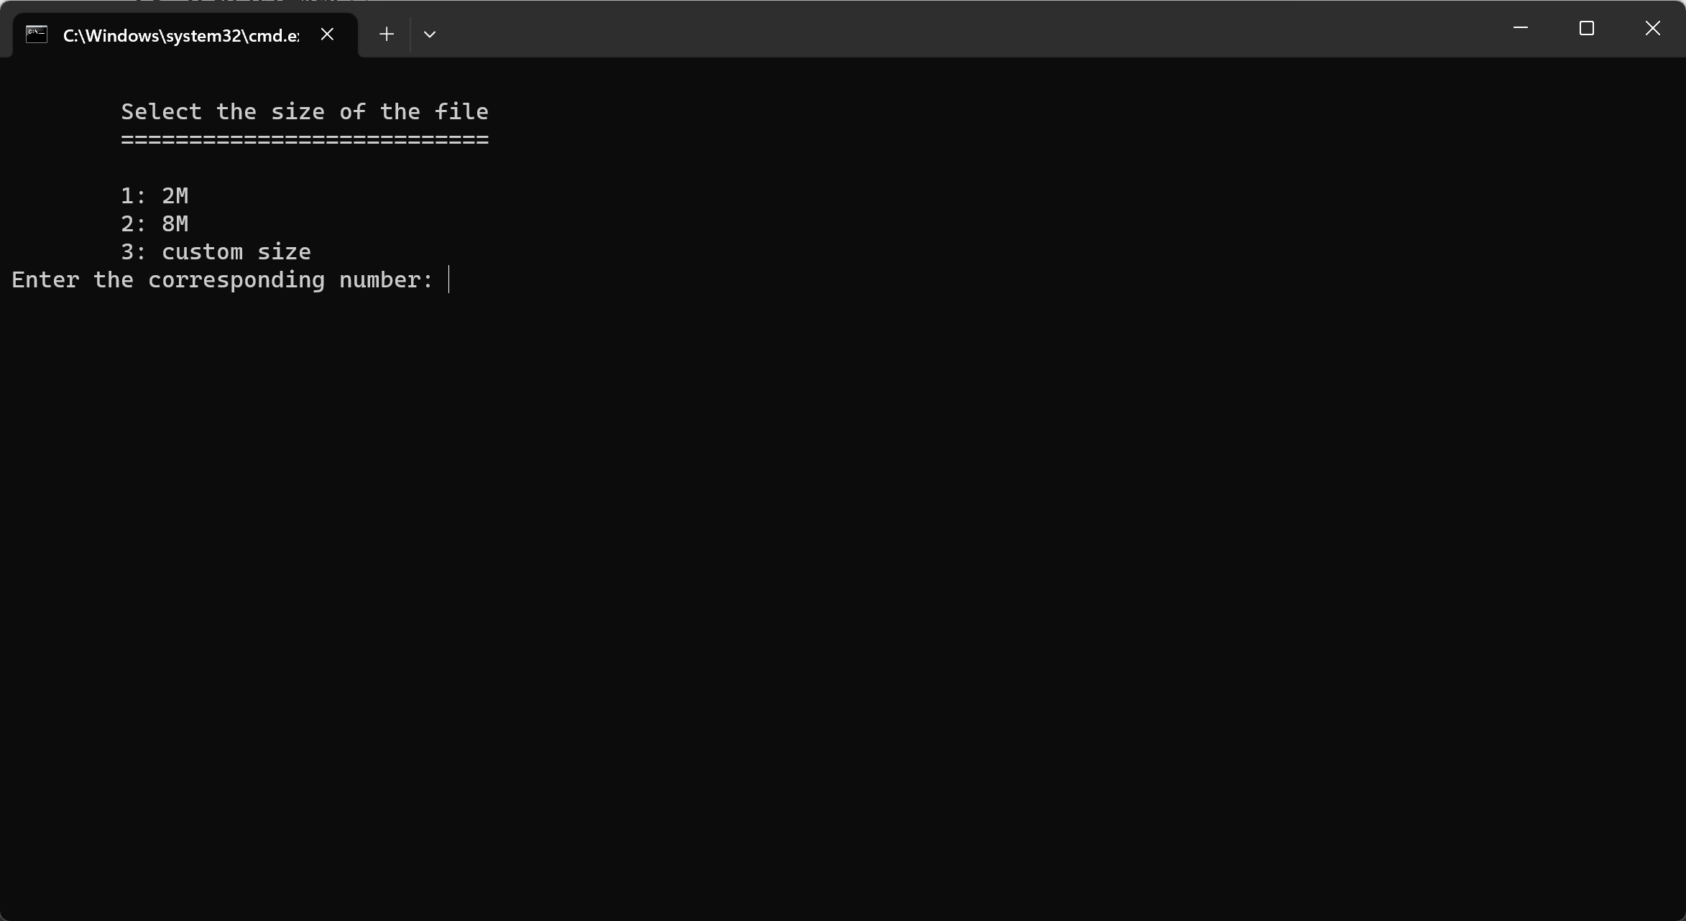
- Select the internal or external flash file system that you want to make (option 3 for customized file system size)
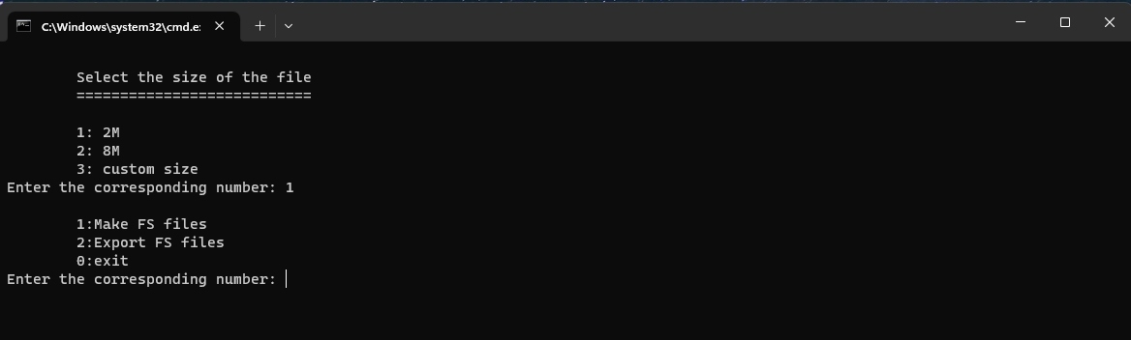
- After that, we choose the 1st option, make the FS file, and generate the customer _fsbin is the FS file that is produced
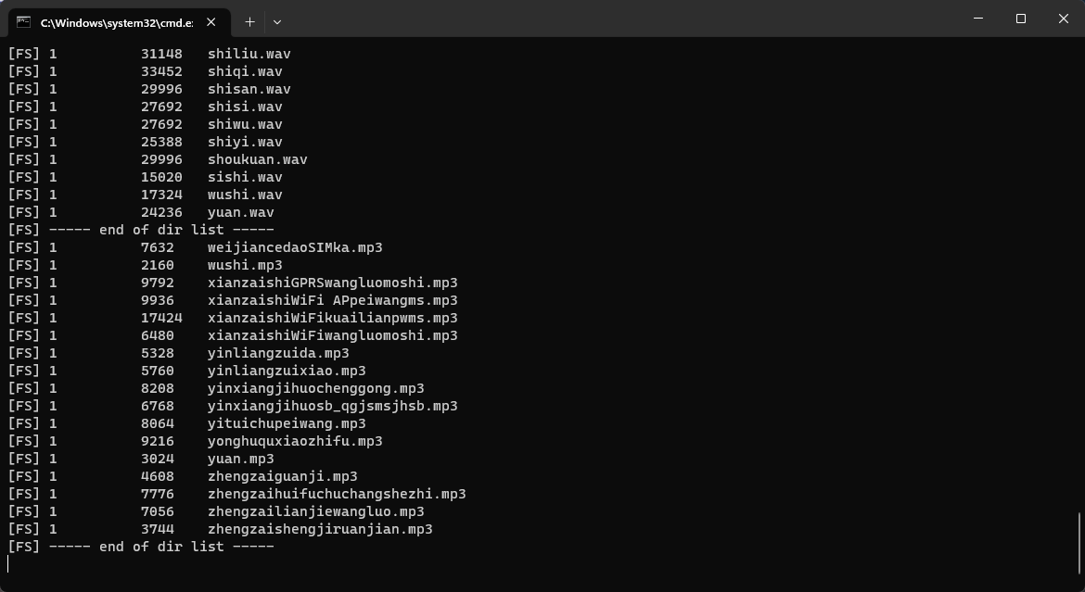
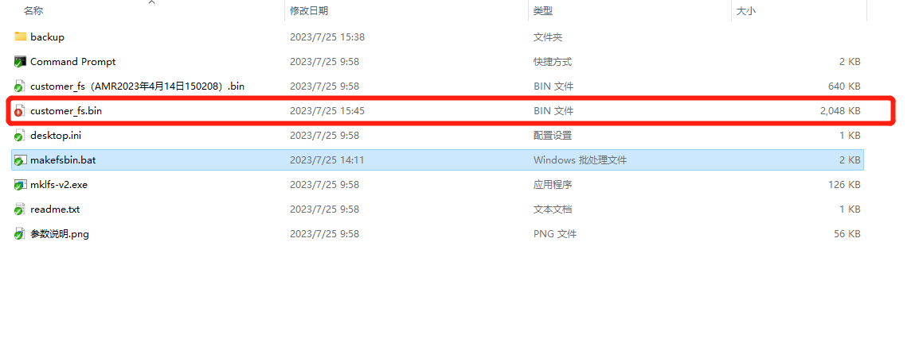

- Export files from the file system
- Change the file name of the FS file to be exported to customer_fs.bin
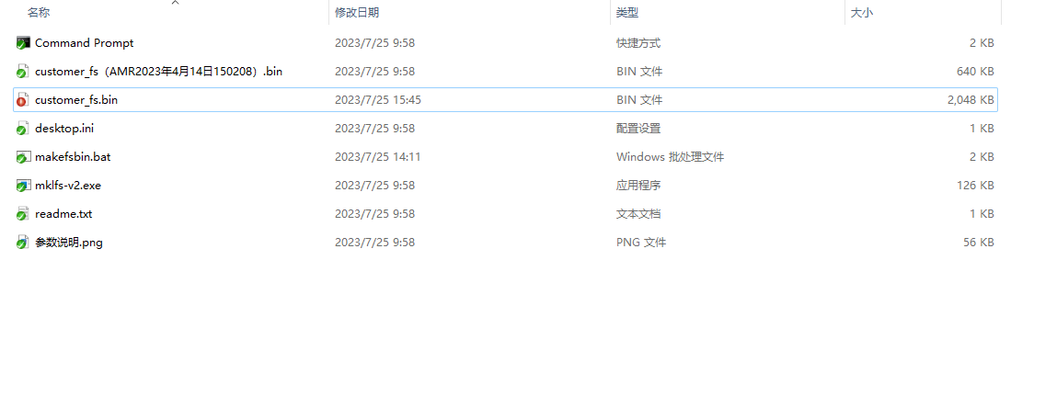
- Run the script and select or enter “customer_fs.bin” file size（we choose 1 on demo）
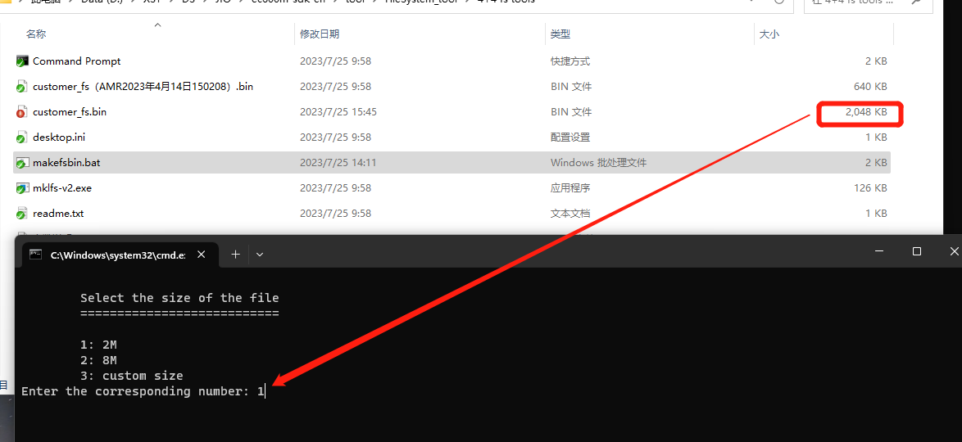
- After confirmation, select option 2 to export the file
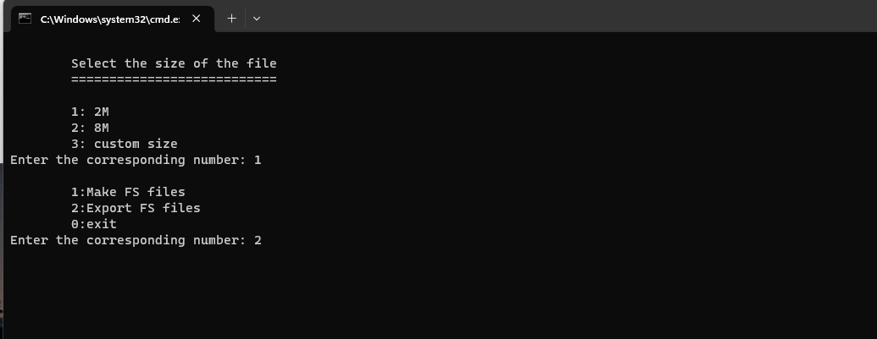
- The exported file is stored in the backup folder
